Automatic masking film laminating and rewinding machine ZRT-400AT

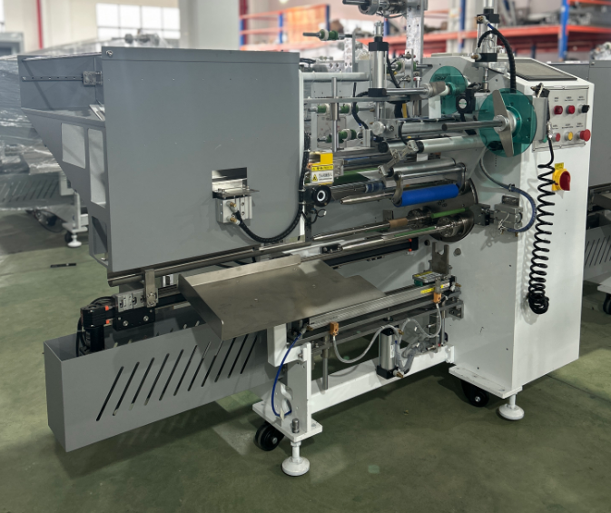

Equipment layout：
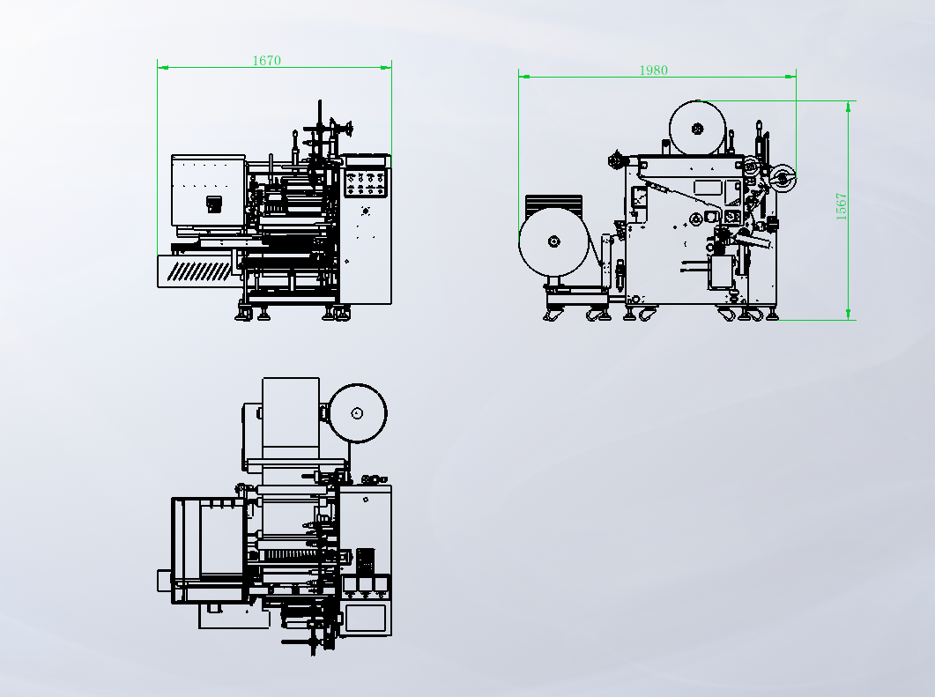
Basic Use：
Mainly used for rewinding and laminating devices and film rolls for masking films.

Product characteristics：
- HCFA motion control card system, servo motor for material pulling, servo motor for torque winding, servo motor for shaft replacement, servo motor for tube threading, servo motor for paper feeding tube, stable and efficient.
- The winding is smooth, the start and stop are stable, and the edge correction is controlled.
- Automatic threading, automatic cutting, automatic finishing, automatic discharging,
- Automatic tension unwinding, stable tension and smooth fit. Start and stop the volume smoothly.
- The servo motor pulls the material, and the length is calculated accurately.
- Servo motor torque winding, stable and precise winding tension, exquisite winding, flat end surface
- Unwinding using inflatable shaft, loading and unloading convenient, fast
- Two tape feeding shafts can be placed, which can produce two layers of tape
- Equipped with an automatic labeling unit at the tail end.
- Tungsten steel round knife is used to cut the material, which is durable and neat.
- No film alarm, no tape alarm, no material alarm, no paper tube alarm and shutdown.
- One key to start, easy to operate

Main Technical Parameters：
Model | ZRT-400AT
paper core | Customized according to customer requirements
Unwinding master roll | ≤600mm
Rewinding diameter | <100mm
Rewind width | W（50-400）mm
Production speed | 4-7pcs/MIN  Subject to rewinding length
power supply | 1P220V 50/60HZ/3.5KW
air pressure | 5KG/CM2
Machine size | 1980*1670*1567
Net Weight | 450KG

Configuration Parameters：
model | SZT-400AT
touch screen | 10inches MCGS
Motion controller | HCFA
servo motor | HCFA
Axis changer servo drive | HCFA
servo motor | HCFA
Pulling Servo Drive | HCFA
Winding Servo Motor | HCFA
Winding Servo Drive | HCFA
Pipe threading servo motor | HCFA
Pipe threading servo driver | HCFA
Drop tube Servo Motor | HCFA
Drop tube Servo Drive | HCFA
stepper motor | Reiter
Stepper Motor Driver | Reiter
Tension controller | impqc
motor | sanly
reducer | Hasi Mai
Edge corrector | BIANFU
Magnetic powder clutch | WREZUN
air switch | chint
switching power supply | Mingwei
Stepper Motor Power Supply | Mingwei
Edge correction power supply | Mingwei
Linear guide | Rich
photoelectric sensor | BOJKE
Material detection sensor | BOJKE
Proximity Switch | Yangming
contactor | Schneider
relay | IDEA
Button switch | Kndele
Tri-color warning light | TAYB
Solenoid valve | asicko
Cylinder | STAR
Rodless cylinder | STAR
Linear slide | HIWIN
Magnetic switch | AIRTAC
bearing | NSK，HRB
drive spindle | Anti-stick Nano-coating
nip roll | Silicone lagging (non-adhesive)
scalpel | 40MM tungsten steel round knife
transition roller | Anti-skid belt surface treatment (to prevent material running)

